INTRA-DISCIPLINARY PROJECT-II REPORT

**“AIRLINE MANAGEMENT SYSTEM”**

**Submitted**

by

|  |  |
| --- | --- |
| Mr. Y. VINOD  201FA04453 | Mr. E.SRI HARI  201FA04253 |
| Mr. M.S.K. CHAITANYA  201FA04460 | |

Under the guidance of

***MS. G KEERTHI*** *Asst. professor*

***DR.B. SAMATHA*** *Asst. professor*



**DEPARTMENT OF COMPUTER SCIENCE & ENGINEERING**

**VIGNAN'S FOUNDATION FOR SCIENCE, TECHNOLOGY AND RESEARCH Deemed to be UNIVERSITY**

**Vadlamudi, Guntur.**

**VIGNAN’S FOUNDATION FOR SCIENCE, TECHNOLOGY AND RESEARCH**

**Deemed to be UNIVERSITY**

VADLAMUDI, GUNTUR DIST, ANDHRA PRADESH, INDIA, PIN-522 213



**CERTIFICATE**

This is to certify that the Intra-Disciplinary Project-II entitled **“Airline management System”** that is being submitted by **E.C. Sri Hari (201FA04253), Y. Vinod (201FA04453), M.S.K. Chaitanya (201FA04460)** for partial fulfilment of Intra-Disciplinary Project-II is a bonafide work carried out under the supervision of ***MS G Keerthi, Asst. professor*** *and* ***DR B. Samatha, Asst. professor*** from Department of Computer Science & Engineering.

*MS G Keerthi*  Dr.VenkatesuluDondeti *Asst.professor,CSE* HOD, CSE

Internal Examiner External Examiner

**VIGNAN’S FOUNDATION FOR SCIENCE, TECHNOLOGY AND RESEARCH**

**Deemed to be UNIVERSITY**

VADLAMUDI, GUNTUR DIST, ANDHRA PRADESH, INDIA, PIN-522 213



**DECLARATION**

We hereby declare that the Intra-Disciplinary Project-II entitled **“Airline Management System”** is being submitted by **Y. Vinod (201FA04453), E. Sri Hari (201FA04253), M.S.K. Chaitanya(201FA04460)** in partial fulfilment of Intra-Disciplinary Projects-II course work. This is our original work, and this project has not formed the basis for the award of any degree. We have worked under the supervision of ***MS G. Keerthi, Asst. professor*** *and*

***DR B. Samatha, Asst. professor***from Department of Computer Science & Engineering.

By

YENDLURI VINOD

EDE CHARAN SRI HARI

MS KRISHNA CHAITANYA

Date:

**ABSTRACT**

Airline management system is based on general requirements of any airline. This project provides secure access to the database to all authorized users of the system. This work is handled by user module. New traveling destination can be added by Destination master. New flight schedule between the two destinations can be setup by Flight scheduling module. After successful reservation customer is asked for payment which is handled by payment module. Any request for cancelling ticket is handled by Cancel reservation module. Airline management system generates all the general-purpose MIS reports required by the management from time to time.

**TABLE OF CONTENTS**

1. Introduction 1
   1. Introduction
   2. Objective
   3. Project Description
2. Software and hardware requirements specifications 2
   1. Software Requirements
   2. Hardware Requirements
3. Design 3
   1. ER Diagram
   2. Database Schema
4. Implementation 5
   1. Sample Source Code
   2. Sample Database
5. Results 9
   1. Screen Shots
6. Conclusion 13
7. References 14
8. **INTRODUCTION**
   1. **Introduction:**

Airport Management System is a web application, developed to maintain the details of passengers, flight details in an airport. It maintains information about the personal details of the passengers and their bookings. The passengers have the ability to generate and download their flight ticket in a pdf format. Admin can log in and perform their respective functionalities such as clearing and checking in passengers and generating the flight details. Airport Management System is an application developed in HTML, PHP. It is user-friendly and very intuitive. It is fast and can perform many operations which are necessary for an airport. It is simple to understand and can even be used by people who are not even familiar with the workings of an airport.

* 1. **Objective:**

• Help airlines system in making their business more efficient

• Complete automation of airlines management

• Provide accurate information about the addition and modification of records

• Provide efficient and reliable structure that can handle large number of customer data

* 1. **project description:**

This Airline management system project is able to provide much facility to the airline staff. This project allows user to add record when passenger request to book a ticket. This project use SQL server as back end so it can handle data of very large customer database and all data generated by the airline such as flight schedule, ticket booking detail, customer records, destination places detail etc. This is a very well-structured project so it is very easy to retrieve old records by just few clicks. This is generalized software and can be adopted by any organization for smooth flow of work

**2. Software and hardware requirements specifications**

**2.1 Software Requirements**

1.windows 10 or above

2.xampp 7.4 version or above

3.web browser (Firefox or chrome or Microsoft edge)

**2.2 Hardware Requirements**

1.A system with minimum speed of 2.1 GHz.

2. A minimum ram capacity of 512MB.

3.Harddisk capacity of at least 100MB free space

**3.Design**

**3.1 ER Diagram**

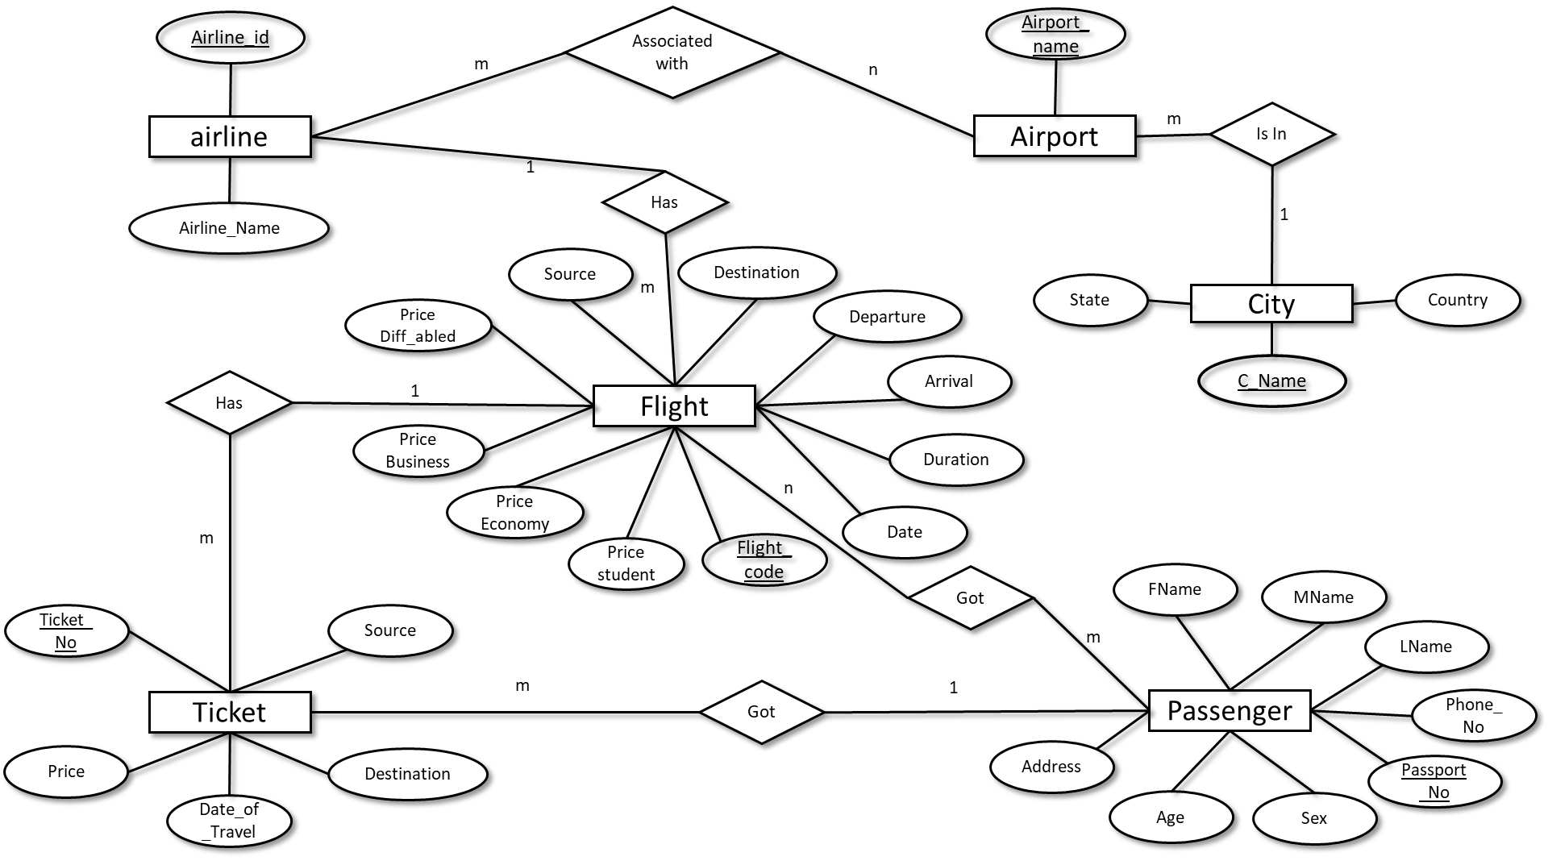

**3.2 Database Schema**

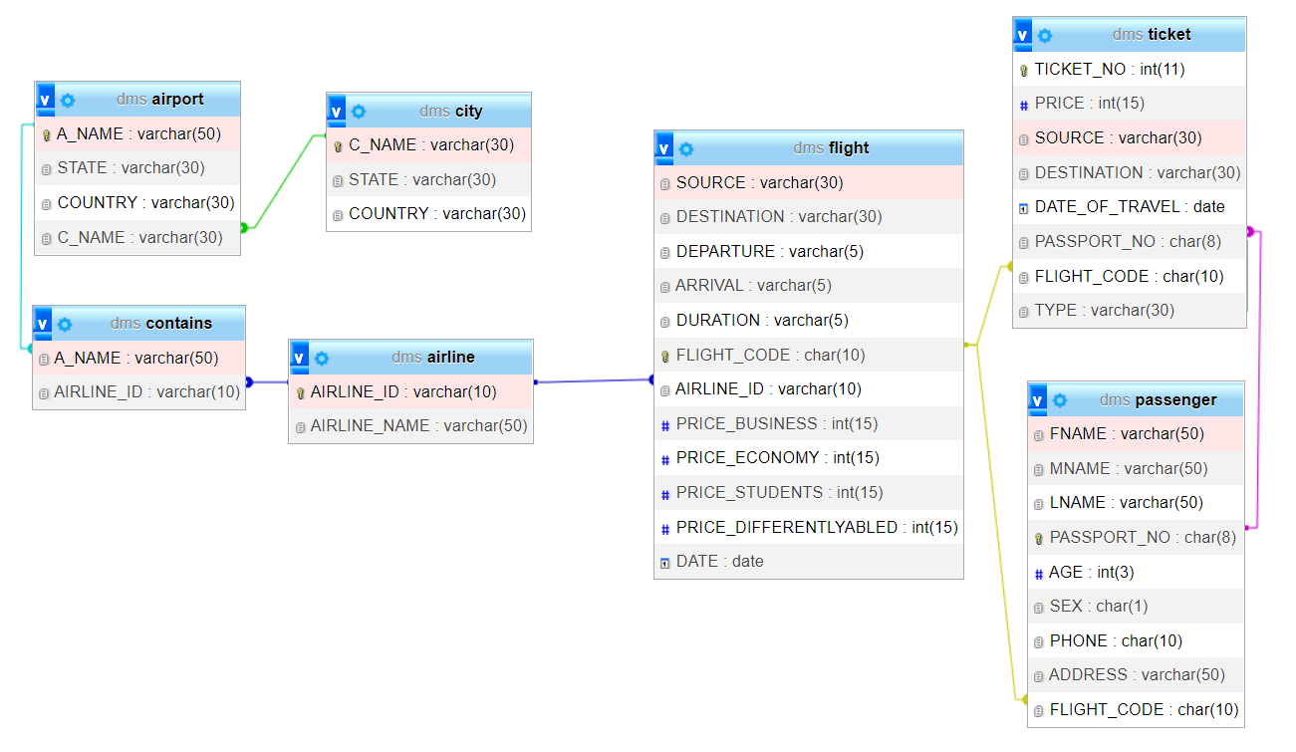

**4: Implementation**

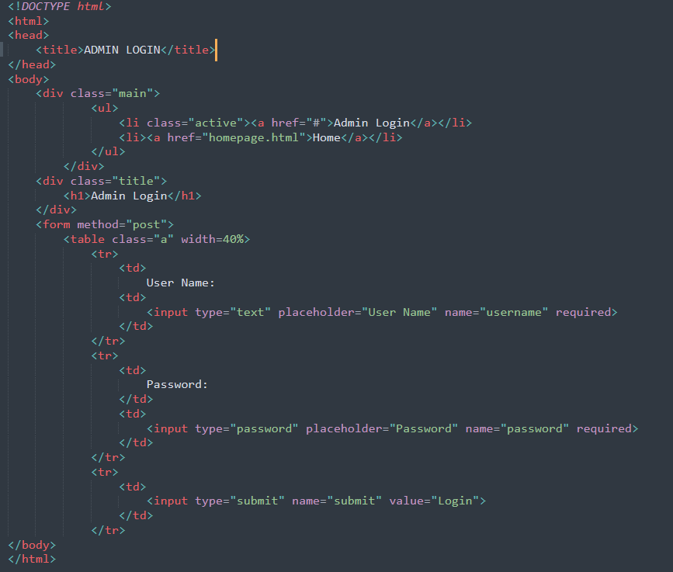**4.1 Sample Source Code**

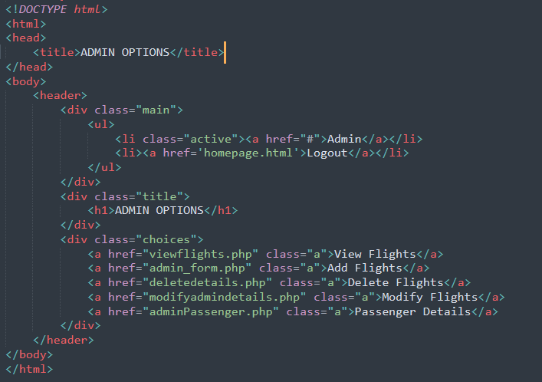

**4.2 Sample Database:**

CREATE TABLE airline (AIRLINE_ID VARCHAR (10) PRIMARY KEY, AIRLINE_NAME VARCHAR (50));

CREATE TABLE airport (A_NAME VARCHAR (50) PRIMARY KEY, STATE VARCHAR (30) NOT NULL, COUNTRY VARCHAR (30) NOT NULL, C_NAME VARCHAR (30), REFERENCES city(C_NAME));

CREATE TABLE city (C_NAME VARCHAR (30) PRIMARY KEY, STATE VARCHAR (30) NOT NULL, COUNTRY VARCHAR (30));

CREATE TABLE contains (A_NAME VARCHAR (50) REFERENCES airport(A_NAME), AIRLINE_ID VARCHAR (10) REFERENCES airline (AIRLINE_ID));

CREATE TABLE flight (SOURCE VARCHAR (30) NOT NULL, DESTINATION VARCHAR (30) NOT NULL, DEPARTURE VARCHAR (5), ARRIVAL VARCHAR (5), DURATION VARCHAR(5),

FLIGHT_CODE CHAR (10) PRIMARY KEY, AIRLINE_ID VARCHAR (10) REFERENCES airline (AIRLINE_ID), PRICE_BUSINESS INT (15), PRICE_ECONOMY INT (15), PRICE_STUDENTS INT (15), PRICE_DIFFERENTLYABLED INT (15), DATE DATE NOT NULL);

CREATE TABLE passenger (FNAME VARCHAR (50) NOT NULL, MNAME VARCHAR (50), LNAME VARCHAR (50) NOT NULL, PASSPORT_NO CHAR (8) PRIMARY KEY, AGE INT (3),

SEX CHAR (1), PHONE CHAR (10), ADDRESS VARCHAR (50), FLIGHT_CODE CHAR (10) REFERENCES flight (FLIGHT_CODE));

CREATE TABLE ticket (TICKET_NO INT AUTO_INCREMENT PRIMARY KEY, PRICE INT (15),SOURCE VARCHAR (30), DESTINATION VARCHAR (30), DATE_OF_TRAVEL DATE,

PASSPORT_NO CHAR (8) REFERENCES passenger (PASSPORT_NO), FLIGHT_CODECHAR (10) REFERENCES flight (FLIGHT_CODE), TYPE VARCHAR (30));

**ScreenShots**

airline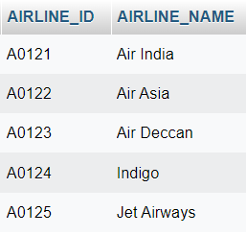contains

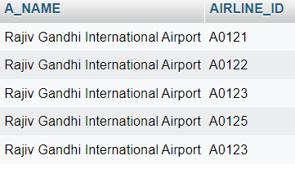

flights

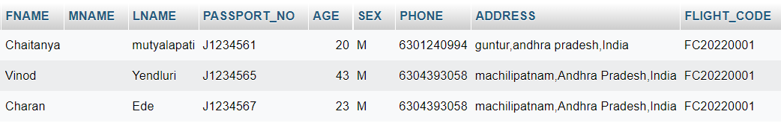 passengers

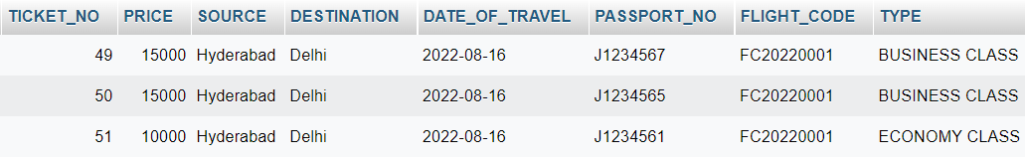 tickets

**5: Results**

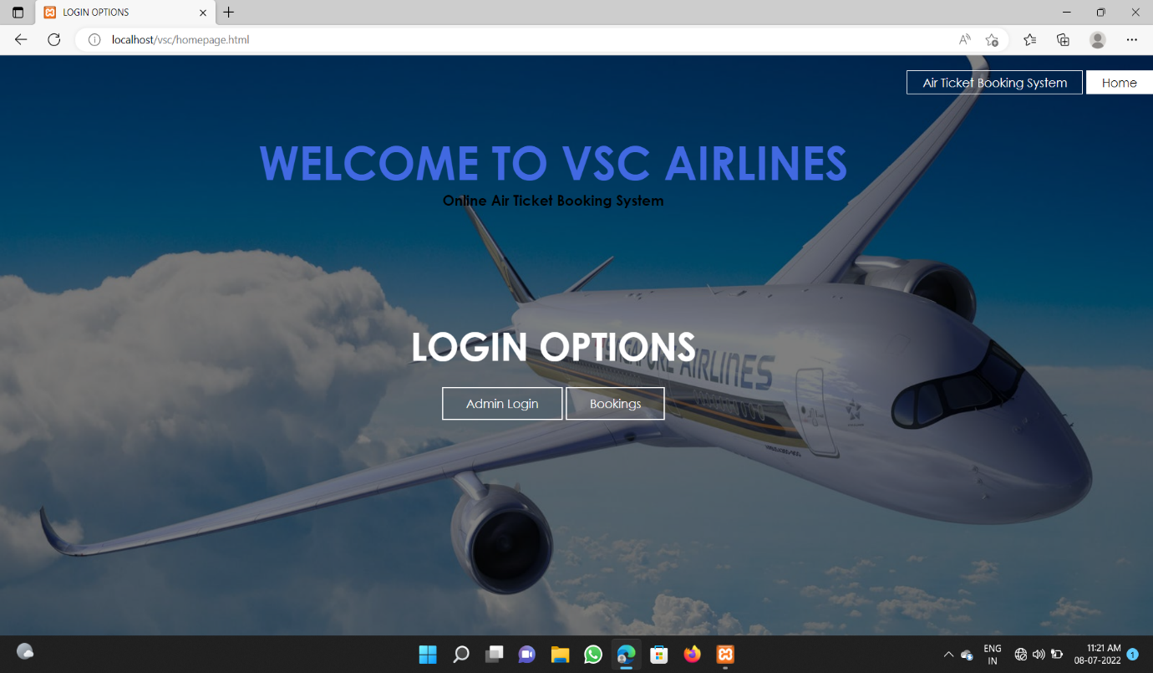**5.1 Screen Shots:**

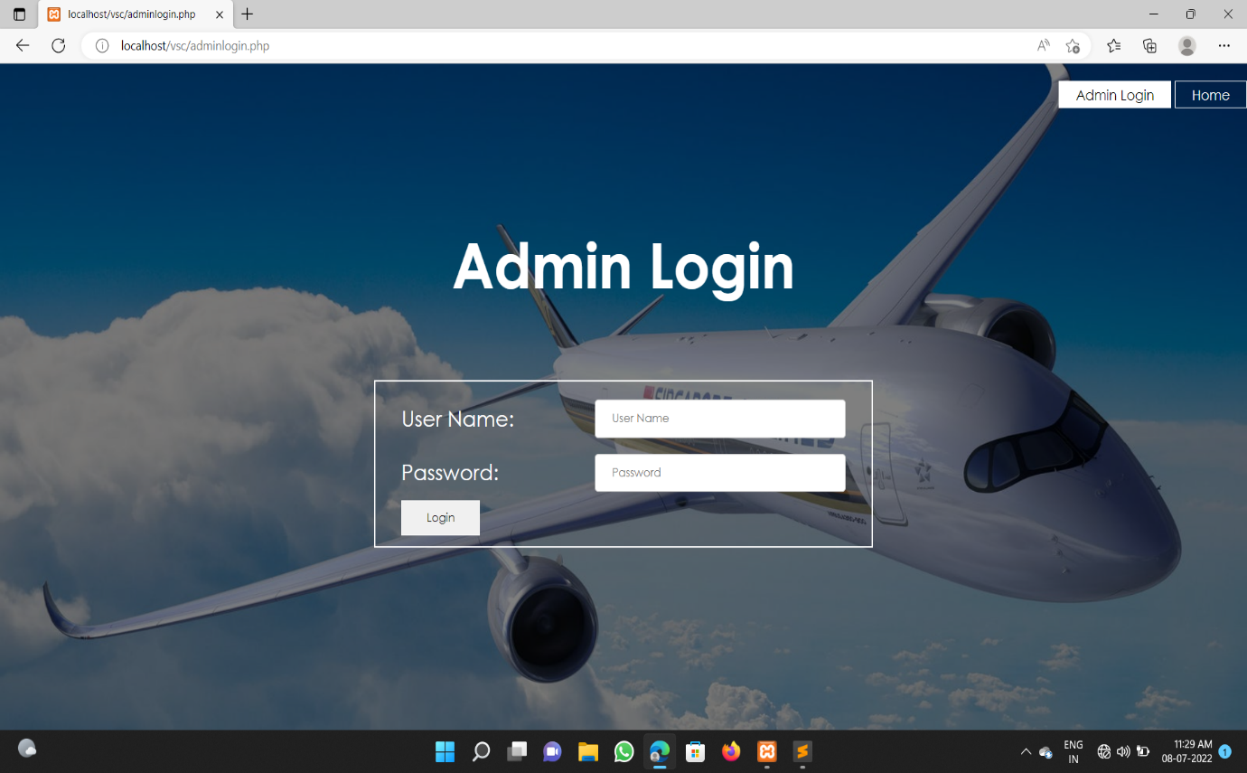

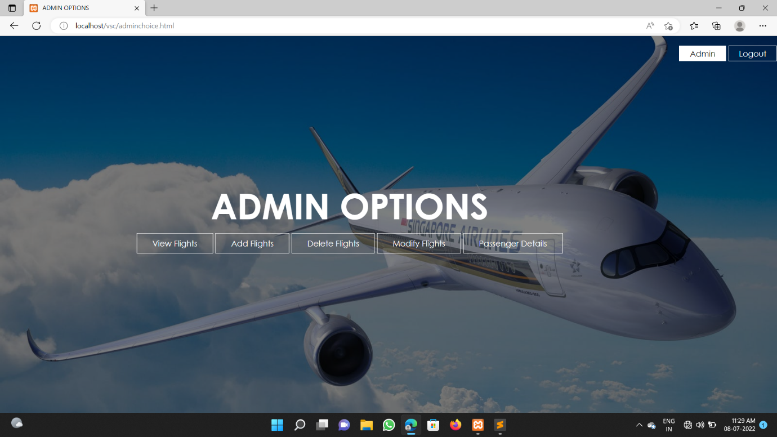

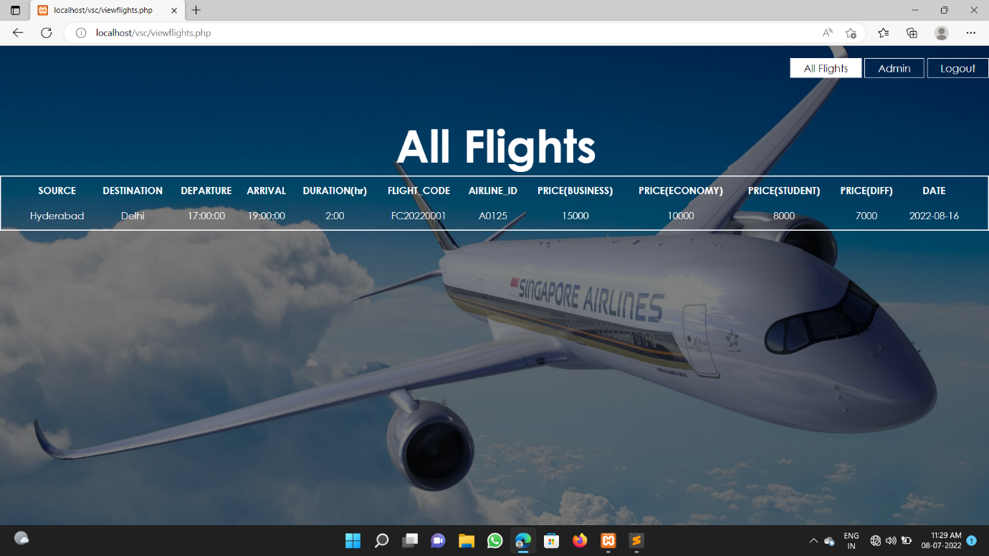

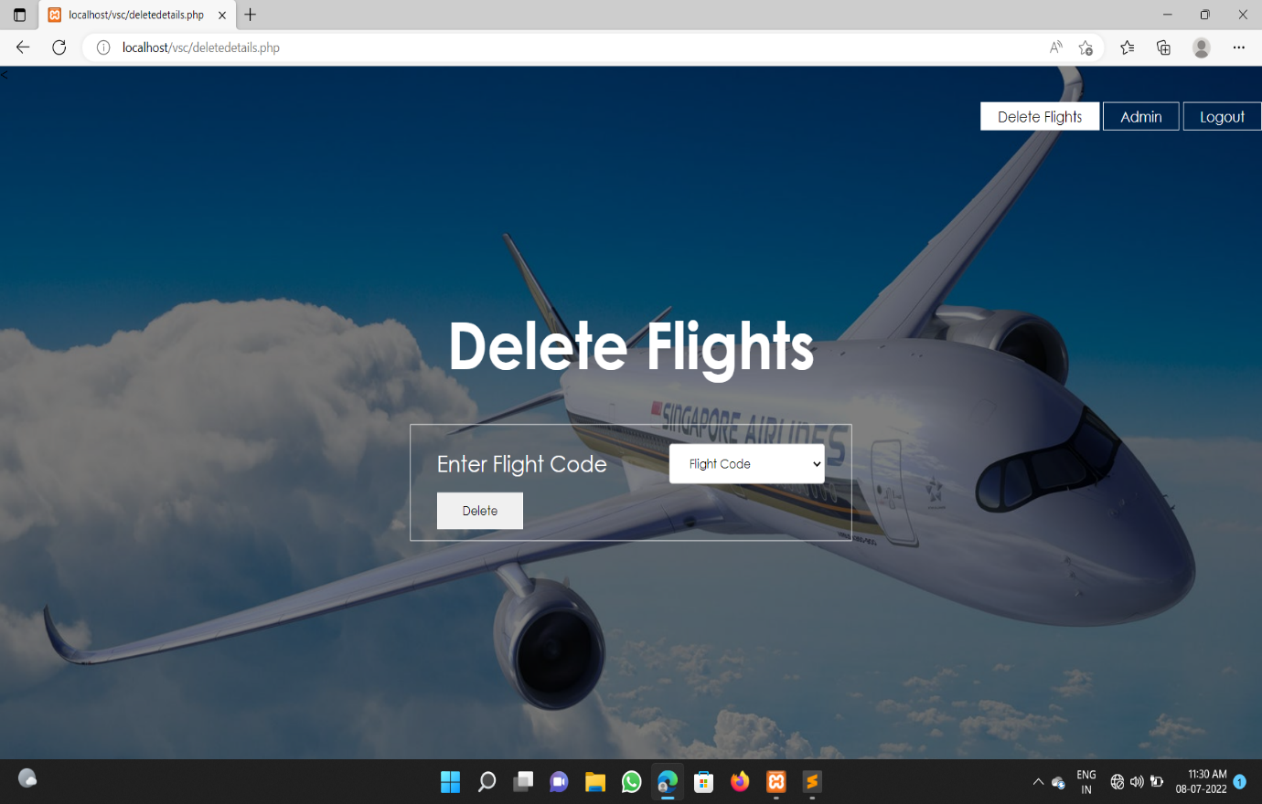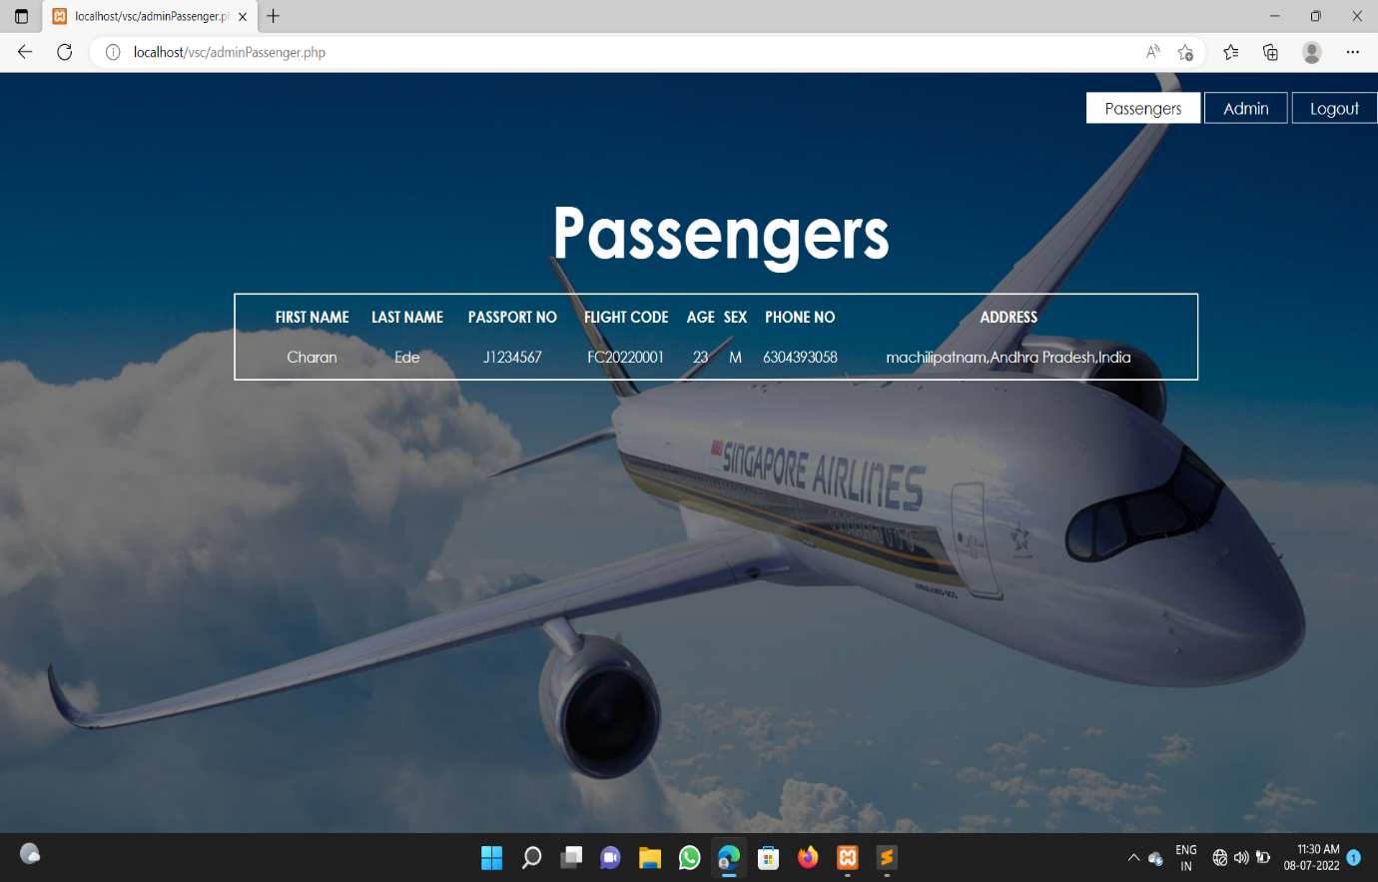

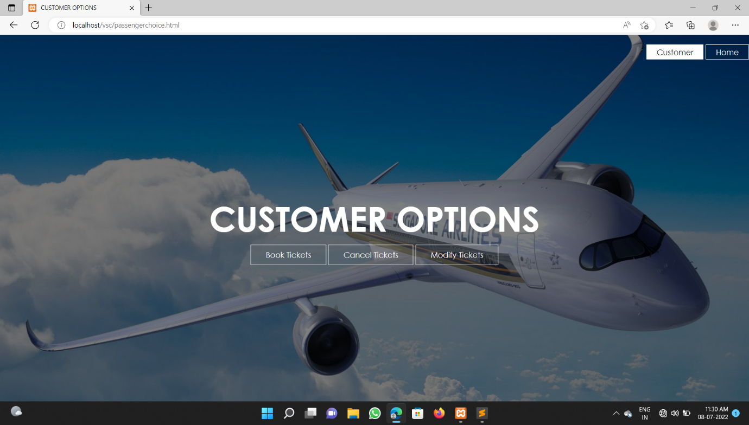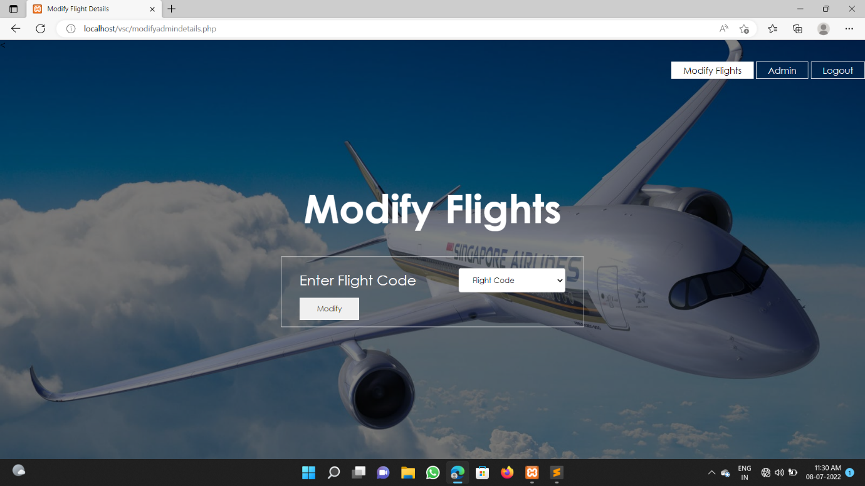

**6 conclusion**

The Airline reservation system has been a way of minimizing the clerical work, which is almost a routine and consumes the most precious time. This AIRLINE MANAGEMENT SYSTEM has been an attempt to help the user to minimize his workload along with minimizing the paper works and saving of time.

The system has been developed in a way to make it very user friendly. It provides an on-line message and an error detection and error messages every time the user needs. Any person having a little bit of window based can run this system without any pain.

Almost all the difficulties of manual booking have been removed by this system. Ti wind up let me welcome all the suggestions and other improvements, which the system needs so that it covers all the needs if the user in the user way.

**7 References**

Web technologies book by Sammulal Porika

<https://www.w3schools.com/css>

https://www.w3schools.com/php

<https://www.w3schools.com/html>